Linux Lab 10 Installing and Removing Software (Ubuntu)

Read
Read CyberAces Module 1 Linux, session 7 Installing Software, in Canvas
The Linux Command Line, chapter 14 Package Management and chapter 23 Installing Software, pp 149 - 157 and 297 - 306 in the printed book and pp 172 -18 and 350 - 361 in the pdf.
These are some good references for how the standard “./configure , make , make install” , sequence works.
http://tldp.org/LDP/LG/current/smith.html (see paragraph 6 for an old Linux joke)
http://www.opensourceforu.com/2012/06/gnu-make-in-detail-for-beginners/

Lab
First, we will install nmap (a network mapping or discovery application, https://nmap.org/ ) using software repositories and the apt commands. Then we will remove nmap and install it from source code to practice using “./configure, make, and make install” to compile and install software.
The main advantages to installing from a repository are that it is easy, and that your application will be automatically updated from the repository in the normal apt-get update; apt-get upgrade cycle. However, the repository does not always have the most current version of the application. If you need a version that is not in the repository, or one that is specially compiled, you will have to install from source code. If you do install from source code, you will have to update the application manually.
1) Is nmap in our repository? Sometimes the name is slightly different from what we think it is, or the application is not in the repository. Page 152 of The Linux Command Line shows us how to check. (Note: the command
apt update
will update the VM’s database of available software, and is run before doing anything with apt.) You will get multiple answers--you are looking for one that starts with ‘nmap’.
sudo apt update
apt search nmap
Note: You can also Google something like “nmap install ubuntu” to find the name that nmap goes by in apt.
2) Check to see if nmap is installed. From the text, page 155, we can use dpkg (Debian Package Manager) to see if nmap is installed. On my Ubuntu 18 VM, it was not installed.
dpkg --status nmap or dpkg --list | grep nmap
or we can use apt
apt list --installed nmap
Repositories (you can think of them as app stores) are the easiest way to install software, but you’re relying on someone to put the program you need into the repository, and it may not be the most current version. However, if the version supplied in the repository meets your needs and is kept up to date, your best choice is to install using apt and the repository. That way, you can update all your software by just typing apt update and apt upgrade. If you install from source code, you’ll have to apply patches yourself.
Nmap also kindly supplies precompiled versions using RPMs, which are packages built for Redhat. You can see simple instructions for using these at https://nmap.org/download.html, in the section “Linux RPM Source and Binaries.” They don’t provide Debian Package Files (.debian) that we can use with Ubuntu, though.
3) Install nmap from the repository. Once you know the package name, it’s easy.
sudo apt install nmap
When you’ve finished, the status command we used before should show that it is installed.
dpkg --status nmap
Run sudo nmap -h. What version of nmap do you have installed?

4) Remove nmap (Optional)
Note: Installing nmap from source code in Ubuntu 22 is messy at the time this is written. If you like, you can skip removing nmap and reinstalling it from source code. If so, read the paragraph about tar and then skip ahead to review. If you are an intrepid Linux user, go ahead and remove nmap and install from source code.
sudo apt remove nmap

5) Install nmap from the source code. (Optional)
When you install from source code you can make sure you have the latest version, or the version you want. Remember that if you install from source code, apt upgrade won’t help you; you’ll have to install updates manually.

Install Dependencies
Since we are compiling from source code, we will need to install a compiler and related development software. This command does that quickly. (You may find that it is already installed.) Whenever you install new software be sure to run apt update first so that your apt database has the correct file download locations.
sudo apt update
sudo apt install build-essential
Many source code installations depend on other software or libraries (dependencies) to be installed first. Generally, I try to install the software and then use the error messages and a search engine to find the missing dependencies. It can be a frustrating and time-consuming process. Install these dependencies.
sudo apt install libpcre2-dev
sudo apt install libssl-dev
sudo apt install python3-build
sudo apt install python3-setuptools
sudo apt install python3.12-venv
Note the -dev libraries above. Ubuntu already has the libpcre2 and libssl libraries installed, but the nmap installer will say they are missing. This is because the installer needs additional information about those libraries to compile software that references them. The additional information is contained in -dev files. This is a common problem when installing from source code; the library may be present on the machine, but the installer needs the -dev files.

Download and extract nmap
Go to https://nmap.org/download.html and download the latest tarball of nmap—it’s at the bottom of the section called “Source Code Distribution,” labeled “Latest Stable Nmap release tarball.” The tar, or tape archive program, is used to put multiple files into one file and optionally compress them. (Tar (tape archive) files are often called tarballs. Tar was originally used for backup--the files on the computer were put into a tarball (a single file, like zip but without compression) and the tarball was then saved to magnetic tape.) Nmap now compresses its files with bzip2 rather than gzip.
Save the file rather than opening it with the web browser. If you are a hard core terminal person, you can download using curl or wget. You still must know the download URL, though. You can often get the link using right-click “copy link location” in the browser, and then pasting it. As I write this, the link is https://nmap.org/dist/nmap-7.92.tar.bz2.
If you download the file using the browser in the VM, it will be in the ~/Downloads directory.
Extract the nmap files using the tar program. You'll need to use the options to extract (-x) and uncompress (use-j for bzip2 or -z for gzip files, depending on which one you downloaded) the files. It's nice to use the verbose option (-v) so you can see what's going on, and you'll need to use an option (-f) to tell tar that the data is coming from a file (and what its name is.) It doesn't matter much what directory you untar the file to. I chose to move the tarball to my home directory before uncompressing it, although a neater user will create a directory for source files. You may need to install bzip2 to extract the bzip2 file.
sudo apt install bzip2
tar –xjvf nmap-[version].tar.bz2 (bzip2 compressed) or
tar -xzvf nmap-[version].tgz (gzip compressed)
Note: [version] will be different, depending on what you download
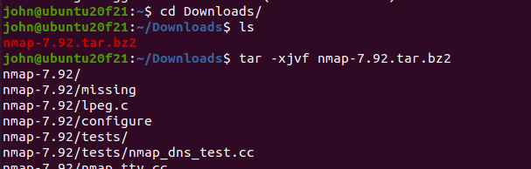
<snip> lots of stuff omitted.

./configure
Change directory (cd) into the directory with the files you just unzipped. For most installations, there is a configure script that does the work of figuring out what distribution you have, where your compilers and libraries are, and it puts that information into something called the Makefile. Look for README and other info files (usually the file names are all Caps.) Also look to see if there is a Makefile. (If configure hasn’t run yet, should will be a Makefile.in but no Makefile.)
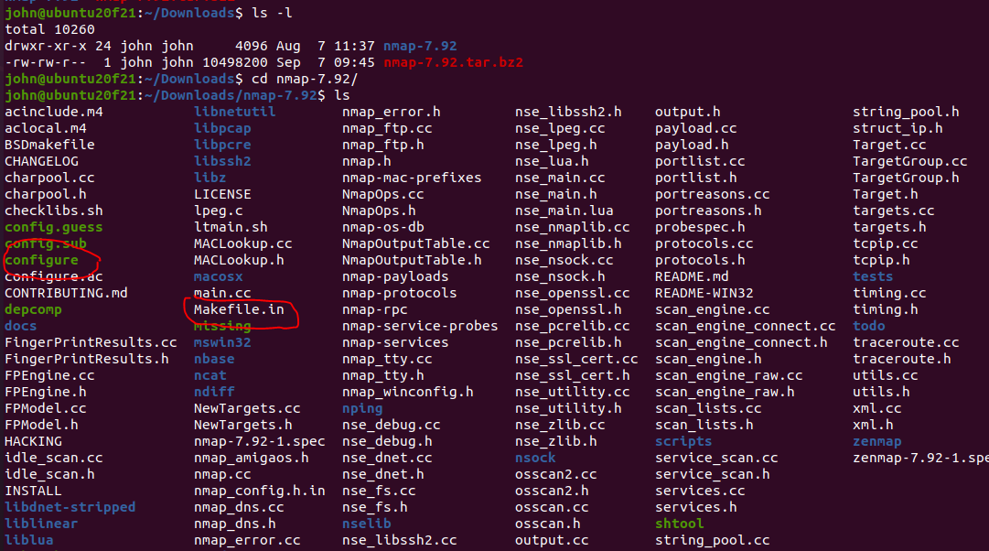
Configure will check to see what your operating system is and what libraries are available. It will put that information into a Makefile.

Note for 2024
There is an error in the configure file that causes it to miss the location of the libpcre2 library in Ubuntu 24. We must tell configure the directory that holds the libpcre2 library.
./configure -with-libpcre=/usr/lib/x86_64-linux-gnu

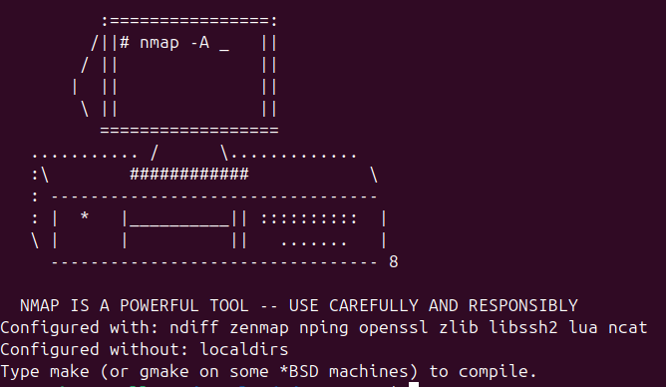

make
The configure script ran many checks, and if they all passed, generated a Makefile. Use ls to look for it. When you did this before, you should have seen only Makefile.in. Now you should see Makefile.in and Makefile. The command make calls a program that is already installed in your OS. If you run, “which make”, you'll see that it lives in /usr/bin/. If it were missing, you’d have to run, “apt install make”. Make saves you the trouble of looking for modules your software depends on (dependencies), compiling each module of the software, putting them in the proper order, and then linking them all together. For complex software, this is a lot of work. All you need to do is type one word:
make
You must type make from the directory that holds your Makefile.
**Why do you type make instead of ./make ?
It will compile about a gazillion many files. If you run ls, you will see a whole bunch of many files that weren't there before. Most of these are *.o files, or object files. They are compiled binary files that can be linked together to run programs.
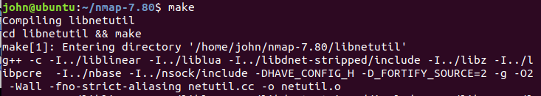
<lots of output deleted>
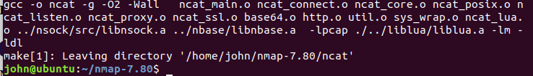
No errors. Whew!

sudo make install
When you run make install, you are telling make that you’ve already compiled the program (see the previous step) and now you want to copy all those object files and binaries into the necessary places on the OS, often to /usr/bin and /usr/local/bin. Those directories require root access, so you’ll have to run as root or use sudo.
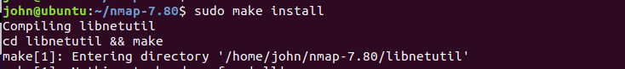
<snip>
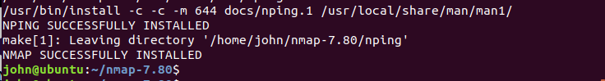
Whew!

Note for 2024
There is an error in make install when it tries to install Zenmap, which is an open issue. https://github.com/nmap/nmap/issues/2714. Nmap runs normally but to run Zenmap you have use
sudo /home/<your username here>/Downloads/nmap-7.95/zenmap
It works!
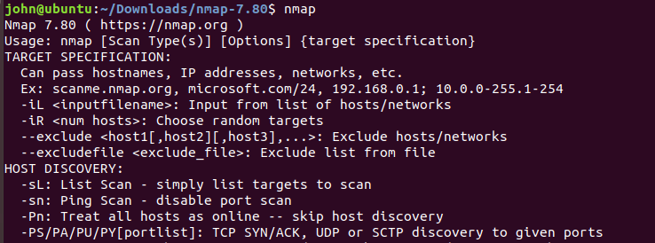
Review
The basic commands we use to install from source code were:
- tar, to decompress the files
- ./configure from the directory tar made, to check for dependencies and create the makefile
- make (same directory as above), to compile all the code
- sudo make install (same directory) to move the compiled files to the proper directories

Hand in
- Were you able to install nmap using both methods? (It’s ok if the source code method didn’t work, it is not easy.)
- What is nmap, anyway?
- What are possible problems with installing programs from source code?

